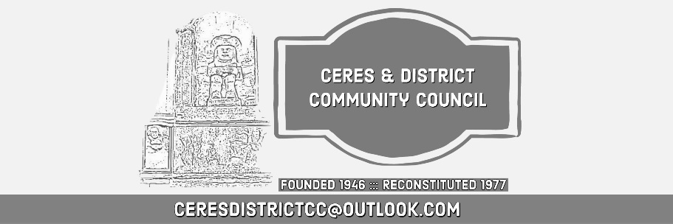
Ceres and District Community Council
Minutes of the Meeting Monday 16 Feb 2026
Ceres Memorial Hall

- Present: Moira Henderson, Alistair Ewan, David Beveridge, Neil Martin, Cllr John Caffrey, Cllr Margaret Kennedy and 18 members of the public, 5 who attended on line via zoom
- Apologies: Susie Whiten, Sandra Smithh

Welcome / Apologies / Chair Introduction:
- The Chair welcomed all attendees to the public meeting, both in the Ceres Memorial Hall and on Zoom, and noted the apologies as received.

Changes to Community Council
- John Hudson has stepped down
  - It is with deep regret that he is departing. His contribution was highly valued. It will be hard to fill his shoes!
- We have Vacancies and need more people to join the community council

Difficulties with Fife Council
- We had intended only to discuss the communication with Fife Council at this meeting and have that as the main item … however following on from the Fife Community Councils” group of CC’s it has been decided to bring evidence to the table from other Fife Cc’s. They seem to be having the same issues as Ceres and District
  - Difficulties with items on our agenda being “stuck” for years
- A long discussion was held with many points being made, lack of process from Fife Council, un-Accountable nature of Fife Council. The broken nature of many departments
  - Duguld Yuill suggested requesting their accountable auditable process.
  - Full support from the present Councillors to take matters further.
  - The CC - Will write to CEO of Fife Council & Scottish Government and Westminster
  - It is unclear where responsibility for Community Councils Lie
  - CC to discuss later who else to enlist in process of addressing Fife Council and the appropriate scope

Expenditure of the CC
  - Erroneous money was paid to the CC in December, Fife council chasing the wrong people to get money back, despite being told who the correct people were.
    - A complaint to Fife Council to be made by the chair.
    - An explanation was made by the Treasurer of CC fund donated to 2 halls and Ceres Community Trust. This was due to build up of funds from COVID time where to room booking fees were spent and was intended to support the community
- An Email from Fife Council has asked for a breakdown of our expenditure!
  - CC does no take expenses for printing etc or travel! This also was highlighted at the last group meeting of CC’s
    - The request was essentially what is in the supplied accounts
  - Cllr Kennedy took an action loo into the rationale for the request about finances.

Ceres and District Trust Update
  - Florian Dargel have an overview of activity
    - Florian - last meeting November.

The Glebe developments
- Start of the bridge in Glebe
- Thanks to people who lent money to allow the bridge building to take place.

Ceres Memorial Hall
  - Ceres Hall - have got a grant to fund installation of solar panels & battery
  - Waiting for planning permission (listed building)
  - Thursday holding a volunteer meeting
  - Thanks to the Trust for all their work.

SCOTO Scottish Community Tourism
  - Initiative for meeting regarding the Pilgrims Way, promoting tourism
  - Report in March, The Trust looking to apply for funding

Ceres on the WEB
- The Chair pointed out that the description of Ceres on the web was poor
- Wording on how Ceres is described on the WWW needs proposed
- Any Other Buss

Saving Elmwood Collage
- A public meeting will be held on Thur 26th Feb in the Corn Exchange at 7pm Growth Study by Prof Boyd

Baltilly Planning ARC at North Fife Planning Committee on the 11th of February
- Baltilly Planning ARC at North Fife Planning Committee on the 11th of February 2026
- Ceres and District Thoughts are available here: Baltilly Development 2026
- Key points are regarding drainage and speed/traffic
- Availability of accessible property is an issue in Fife with waiting times stated as Waiting time for accessible property at 98 years

Traffic Matters

Craigrothie
- Craigrothie Parking on speed table-update
  - Cllr John Caffrey took an action to request white zigzag lines one both sides of the raised platform in Craigrothie
  - Additionally the fencing at the entrance to Old Mill Road has been damaged due to a car collision. Repair is requested from Fife Council and should be covered by car insurance of the driver.
- Craigrothie parking Walton Park- update
  - All applications for wavers for parking on pavements have been denied by Fife Council. So the new law stands.
- Potholes and drainage problems Craigrothie
  - Drainage at the corner of the Cupar end of main street in Craigrothie continues to be a problem with heavy rainfall. Flood water goes down Old Mill Road and floods houses on the North side of the road. Given the drains ultimately enter into the Craigrothie Burn it would seem that a more direct route would alleviate the problem.
- Chance Inn-parking on the corner and flooding at bottom of the hill has been reported as problem particularly for Agriculture vehicles. There are no lines so no enforcement policy is in effect.
- No response has come from the

Ceres
- Bishops Bridge requires remedial work
- There is ivy overgrowing the Provost of Ceres monument and needs Fife Council Attention
The Meeting Ended: 9:00pm
Next Public Meeting: Monday 11 May 2026 at 7:30pm, Craigrothie Village Hall

